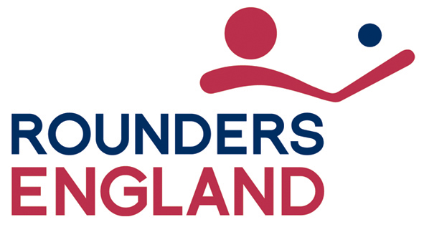Rounders England Selection Policy

Eligibility

To represent England, players must have
- been born in England, or
- resided permanently in England for the 3 years prior to the date of the trial, or
- have a parent or grandparent who was born in England.

Selection for age related teams (e.g. U14, U16, U21 and Senior) will be based on player’s ages at 1st September in the year of the trial.

Players may play for older age groups, in line with Rounders England policy on Long Term Participant Development (LTPD).

To play for England, players must be members of Rounders England.

Selection

Players must pre-register for trials and pay the identified fee prior to participating.
Selection will be made following assessments of performance carried out by selectors appointed by Rounders England.

Selectors will be:
- Rounders England registered coaches with UKCC L2 or equivalent qualification or
- Volunteers who have undertaken Talent Identification Training.

Selectors with a vested interest in players attending the trials e.g. a relative, must declare their interest and will not have any input to the selection of that player’s team or squad.

Players unable to attend the trial may not be considered for selection unless their non-attendance can be medically certified. Proof must be provided in the form of a doctor’s letter or medical certificate. Any such cases will be assessed, on their own circumstances, by a panel convened for this purpose. Players may then be invited to trial at a deferred trial, where the same criteria will apply.

Commitment

Once selected, players are expected to show a high level of commitment. This includes the expectation that they will attend all training sessions and matches.

Any player missing two or more events in any one season will be deselected. Only in exceptional circumstances (e.g. illness, injury, bereavement, religious festival) will de-selection, following two or more absences, not take place.

All players must follow the ‘National Squad Player Code of Conduct’. Failure to do this may lead to de-selection.

All cases of de-selection will be assessed on their own circumstances. Initial decisions will be made by the team coach in consultation with the Head Coach.

February 2018 (England Coaches meeting)
June 2019
Date of next review: 2020

