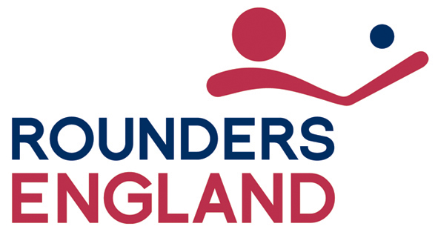

Digital Marketing Assistant – Person Specification

Qualifications | Definition
Essential | Degree or equivalent (CIM) with evidence of Continuing Professional Development or 2 years work experience in a similar role | A
Desirable | Full current driving license | A

Experience | Definition
Essential | Experience using a CMS | A & I
 | Experience in writing and editing for the web | A & I
 | Excellent working knowledge of the main social networking sites and a passion for social media and the web | A & I
 | Effective decision making and time management | A & I
 | Ability to analyse data to impact the strategies of Rounders England | I
Desirable | Understanding of Rounders England’s markets and customers | A
 | Experience of authoring materials specifically for web use | I
 | Experienced in communicating with a wide variety of audiences including the media | A & I

Knowledge | Definition
Essential | Understanding of marketing principles | A & I
Desirable | Understanding of the Rounders England brand | A & I
 | Awareness and understanding of equality issues and safeguarding issues | A
 | Knowledge of database concepts | A & I

Technical, competencies  and aptitude | Definition
Essential | Excellent knowledge of MS office and internet expertise | A
 | Good working knowledge of Content Management Systems, specifically wordpress | A
 | Proficient with desktop publishing software (Adobe Photoshop) | A & I
 | Organised and able to meet timelines and targets | A & I
 | Possess a sense of ownership and can demonstrate an active approach to tasks | A & I
 | Ability to work with a diverse group of people; organisation members, colleagues, media, partners, Sport England etc | A & I
 | Ability to work within a team and respect the individual values of the people that work within it. Always open and curious to learn from others with different opinions | I
 | Can do attitude and always seeking better ways of working | I
 | Strong communication skills | A & I
 | Working knowledge of Google Analytics | A & I
Desirable | Knowledge of other graphics packages i.e. canva | A
 | Can handle multiple projects | A & I

A = Application, I = Interview

September 2021 Julia Rice

