Striking and fielding skills
1
Tip and run

How to play
- Divide your group into pairs with one batter and one fielder. Place two cones on the floor a set distance apart for each pair.
- The batter collects a bat and bean bag, ball, or toy and goes to stand at one of the cones.
- The batter pushes or hits the bean bag into a space and then runs to the other cone.

- The fielder runs to collect the bean bag and return it to the batting spot.
- The batter runs back to the batting spot and has another go.
- After three or four turns the players swap roles.

Equipment
Cones or markers

Range of different sized racquets or bats
Bean bags Balls
Soft toys

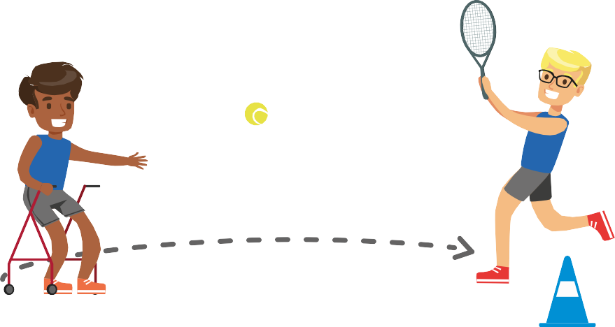

- Striking and fielding skills: Tip and run

Using STEP Impairment specific considerations

Blind and visually impaired pupils
 | Easier | Harder
Space | - Reduce distance between the cones. | - Increase distance between the cones.
Task | - Bean bag, ball,  or toy can be pushed  along the floor. | - Bean bag, ball, or toy must be hit towards a specific target.
Equipment | - Remove the bat, pupils can throw / propel object using their hand. | - Change racquet  or ball to reduce the size / surface area.
People | - Pupils to practise hitting bean bag  or ball individually. | - Introduce a bowler to the group.

  - Use a high visibility ball and / or audible ball.
  - Introduce a buddy system.

Pupils with a learning disability
  - Encourage pupils to think about accuracy rather than strength when hitting the bean bag.

Deaf and hearing-impaired pupils
  - Demonstrate the activity to the group before you start the activity.

Pupils with a physical impairment
  - Objects to be propelled along a higher surface. E.g. table.
  - Use a Velcro mitt or glove to support players with reduced dexterity.
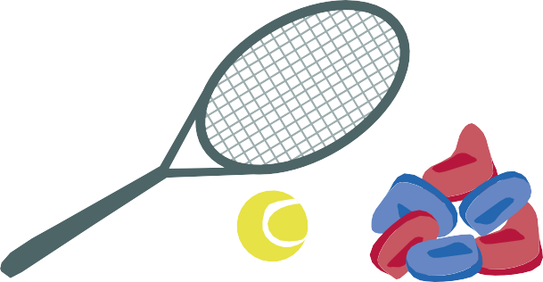

Striking and fielding skills
2
Tee strike

How to play
- Divide your group into pairs and give each pair one striking tee or large cone and a large soft ball.
- Player one is the striker. They stand at
the tee or cone with the ball placed on top.
- Player two is the catcher. They stand approximately 8-10 paces in front of the striker.

- With the ball stationary on top of the tee or cone, the striker hits the ball with their hand towards the catcher.
- After each strike the catcher returns the ball to the tee / cone.
- Have a few turns the players swap roles.

Equipment
Large playing area

One striking tee or upright cone per pair
One large soft ball per pair

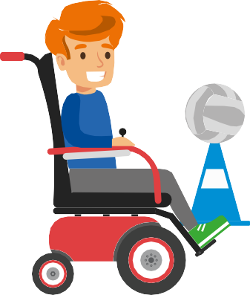

Pupil corner - Challenge your classmates to:
- Aim for more targets.
- Create a game like Tee Strike and include counting.
- Use other parts of the body to hit the ball.

- Striking and fielding skills: Tee strike

Using STEP Impairment specific considerations

Blind and visually impaired pupils
 | Easier | Harder
Space | - Reduce distance between the striker and catcher. | - Increase distance between the striker and catcher.
Task | - Pupil simply practise hitting the ball  off the tee rather than aiming it  to the catcher. | - Remove striking tee and replace with bouncing the ball before each strike.
Equipment | - Allow players striking the ball to wear a glove. | - Players to use  a racquet or bat  to strike the ball.
People | - Striker can hit the ball to anyone. | - Catchers decide where the striker should hit the ball.

  - Use a high visibility ball and / or audible ball.
  - Catchers to wear high visibility / colourful bibs.

Pupils with a learning disability
  - Encourage pupils to think about accuracy rather than strength when hitting the ball.

Deaf and hearing-impaired pupils
  - Demonstrate the activity to the group before you start the activity.

Pupils with a physical impairment
  - Striking and catching can be done from a seated position or using a different body part.
  - Use a Velcro mitt or glove to support players with reduced dexterity.

Striking and fielding skills
3
Wall target rounders

How to play
- Divide your group into two teams.
- Position the two teams back-to-back.
- Give each player three balls.
- Set up several targets on the edge of the playing area using cones, markers, and hoops.

- Players hit their balls towards the targets in front of them. If their balls hit or land in the target, they win points for their team.
- The team with the highest points total wins the game.

Equipment
Large playing area
Cones, markers, and hoops

A range of bats and racquets
A range of different sized balls

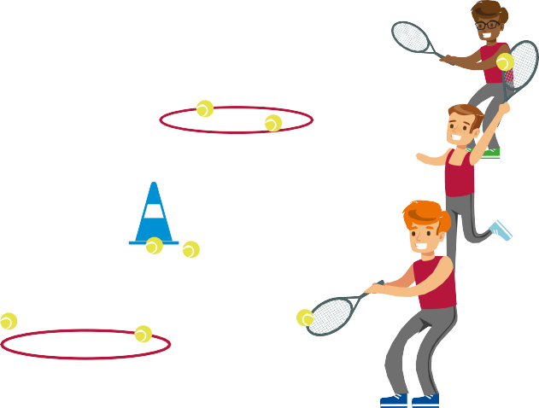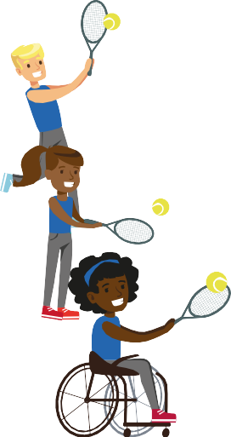

Pupil corner - Challenge yourself:
- Try using a different bat or racquet.
- Create new rules or targets.
- Set yourself a target score to reach.

- Striking and fielding skills: Wall target rounders

Using STEP Impairment specific considerations

Blind and visually impaired pupils
 | Easier | Harder
Space | - Reduce distance between players and the targets. | - Increase distance between players and the targets.
Task | - Players can use different body parts to propel the balls.  E.g. hands or feet. | - Balls are not allowed to bounce before reaching the target. Balls must stay within or touching the target.
Equipment | - Increase the size of the target or use a larger ball. | - Players can use smaller bats, racquets, and balls.
People | - Reduce the number of people in each area. | - Players must use their non-dominant hand to propel the balls.

  - Use high visibility / colourful equipment.
  - Use audible balls where possible.
  - Buddy or guide to provide feedback to player on close or far away the target is.
  - Use sound to support visually impaired players to locate the target.

Pupils with a learning disability
  - Provide a demonstration of the activity.
  - Encourage pupils to think about accuracy rather than strength when hitting the ball.

Deaf and hearing-impaired pupils
  - Demonstrate the instructions visually.
  - Use visual cues. E.g. picture cards, or a flag to indicate start and end of the activity.

Pupils with a physical impairment
  - Pupils can propel, throw, or hit balls or objects from a seated position.
  - May need to use lighter objects. E.g. fluff balls or paper balls.
  - Use a ramp or chute to assist players to propel the balls or objects.

Striking and fielding skills
4
Target rounders

How to play
- Divide your group into teams. Each team has six players with one batter and five fielders.
- Position the fielders in a semi-circle shape around the batter.
- One fielder bowls a ball or object to the batter, the batter then hits the object back to a fielder.

- The batter can decide which fielder to hit
the ball or object to. Or a name can be called out as the fielder bowls.
- Rotate the batter every 4-5 turns.

Equipment
A range of different sized bats and racquets
A range of balls or objects to hit.
E.g. tennis ball,
foam ball, or football

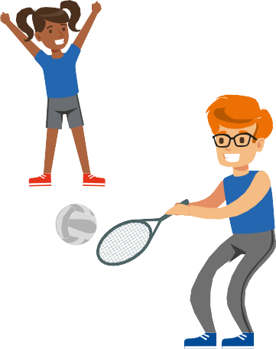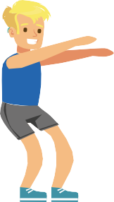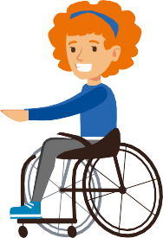

Pupil corner - Can you:
- Change this activity to make it more active?
- Create a way to record scores whilst taking part in this activity?
- Work as a group to improve each other’s skill level.

- Striking and fielding skills: Target rounders

Using STEP Impairment specific considerations

Blind and visually impaired pupils
 | Easier | Harder
Space | - Reduce distance between the batter and fielders. | - Increase distance between the batters and fielders.
Task | - Batter can strike the ball or object off a striking tee. | - Introduce two bowlers and the batter must react to whoever bowls.
Equipment | - Use a bat or racquet with  a large surface area. | - Use a bat or racquet with  a small surface area.
People | - Reduce number of people in each team. | - Increase the number of people in each team.

  - Use of a high visibility ball and / or audible ball.
  - Fielders can say their names loudly so the batter can gage where each fielder is positioned.

Pupils with a learning disability
  - Give clear instructions and use practical demonstration.
  - Clearly signal who pupils should bowl the ball or object to.

Deaf and hearing-impaired pupils
  - Demonstrate instructions visually.
  - Use picture cards to communicate instructions.
  - Fielders signal to the batter who to hit the ball to.

Pupils with a physical impairment
  - 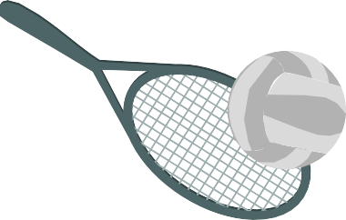Players can take part in this activity from the seated position.
  - Pupils can propel, throw, or hit the ball by using another method or body part. E.g. kick, roll, or use their wheelchair.

Striking and fielding skills
5
Random rounders

How to play
- Place two cones a set distance apart, one for the batter and one for the bowler.
- From the batting cone mark out three different sized running routes.
- Divide your group into two teams, one batting and one fielding.
- The batting team can choose what type of ball and bat / racquet want to use.
- One player on the fielding team is the bowler and bowls the ball to the batter.

- Once the batter hits the ball,
they can decide which running route to take. Each route has different points associated to it.
- The fielding team retrieve the ball and return it to the bowler. The batter must stop running when the bowler has the ball.
- If a fielder catches the ball before it bounces, the batter loses their points and re-joins the end of the batting line.

Equipment
Cones or markers A range of different
sized bats and racquets

A range of different sized balls. E.g. tennis ball, foam ball, or football

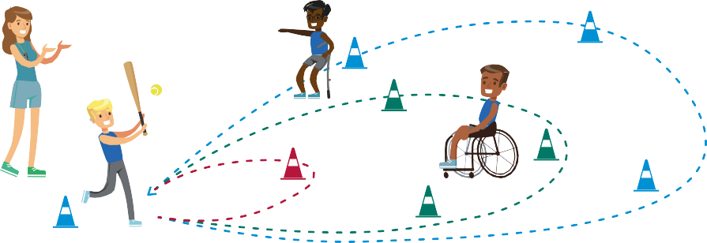

Pupil corner - Have a go at:
- Adapting the activity and roles so everyone in your group is included.
- Creating new rules to challenge players with different abilities.

- Striking and fielding skills: Random rounders

Using STEP Impairment specific considerations

Blind and visually impaired pupils
 | Easier | Harder
Space | - Reduce length of the running routes. | - Increase length / complexity of the running routes.
Task | - Pupils can use a striking tee.  - Pupil can propel the ball using another method. E.g. kick, push, or roll off  a ramp. | - Pupils must hold the bat in their non-dominant  hand to hit the ball.
Equipment | - Use a bat with  a large surface area.  - Use a larger ball. | - Use a bat with  a small surface area.  - Use a smaller ball.
People | - Limit the number of fielders.  - Pupils can have three attempts to hit the ball and choose which one they decide to run on. | - Increase the number of fielders taking part.

  - Use a high visibility ball and / or audible ball.
  - Encourage verbal communication from teammates.
  - Introduce a buddy or guide to support a pupil to run around the rounders route.

Pupils with a learning disability
  - Break down the game into step-by-step instructions.
  - Place floor arrows or cards along the running routes to direct pupils.

Deaf and hearing-impaired pupils
  - Give a visual demonstration before starting the game.
  - Bowler to use a visual signal to show they are about to bowl the ball.

Pupils with a physical impairment
  - Batter can strike ball from a seated position.
  - A ramp can be used to assist players to propel the ball.
  - Offer an alternative route or another teammate to run for the batter.

