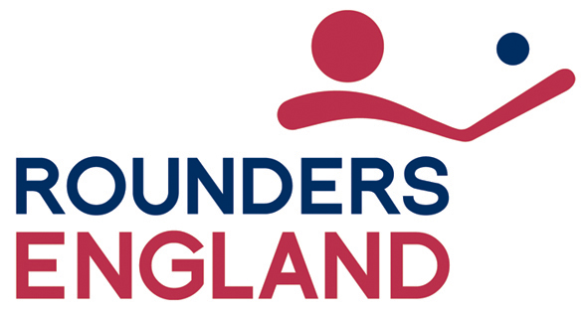

Code of Ethics 2023
The mission of Rounders England is to connect people through Rounders. Rounders England encourages membership to individuals –usually (but not limited to) spectators, players, coaches, officials, and education establishments such as schools, universities and colleges. In addition our membership offer extends to clubs and teams whether established for social reasons or competitive play. We also encourage fans who may develop their interest to a paid membership level in the future.
Inherent within all professional organisations is the potential for conflicts of interest, harassment, abuse of power, and other forms of unethical practice. Through the establishment of a Code of Ethics, Rounders England has defined a set of guidelines to promote and protect the spirit of the game, safeguard the best interest of the participants, and establish and maintain standards of behaviour. The Code is not intended to serve as a set of rules, but rather, to outline general principles and guidelines of aspirational virtues and proper ethical behaviour for all members, volunteers, staff and any other individuals and organisations that choose to be members of Rounders England.
The definition of ethical behaviour is having an understanding of the difference between right and wrong and at all times choosing to do what is right. This definition should be applied at the individual level to those within the Rounders England umbrella: employees, volunteers or individuals who represent Rounders England within the community at large, as well as the corporate level pertaining to the actions of Rounders England, as an organisation. Ethical considerations are integral, not optional, elements of all sports activities and apply to all levels of participation. Rounders England encourages all members to acknowledge and follow ethical guidelines and demonstrate integrity by voluntarily agreeing to adhere to this code.
Participation in the sport of Rounders provides a powerful vehicle for a participant’s personal growth and development, teaching the value of respect, fairness, teamwork, communication, responsibility, truthfulness, non-discrimination, honesty and integrity. These values serve as the core ideals for the Rounders England Code of Ethics.
Respect
A key component of ethical behaviour is respect, which is defined at the individual, team and corporate levels. Individuals should value the opinions, views and roles of others who work to further the aims of the organisation. All should safeguard the dignity, privacy, and freedom of individuals regardless of their age, disability, gender reassignment, marriage or civil partnership status, pregnancy or maternity status, race, religion or belief, sex, and sexual orientation. Neither should an individual’s socio-economic status be a reason for being disrespected. Respect defines the value that Rounders England, as an organisation, places on honouring the history of the sport and demonstrates the regard it shows to the partners that have come together to form Rounders England to further the growth and development of the sport.
Fairness
Fairness is making decisions without favouritism or prejudice. Rounders England firmly believes that the concept of fairness is fundamental to sport. Anything that creates an unfair advantage violates the spirit, as well as the integrity, of the sport of Rounders.
In addition we support and advocate the need for equality, diversity and inclusion in the management of our sport underpinning our core values and our organisation’s culture. It is centric to all our strategic and operational decision-making. Further information can be obtained via our Equality Policy and our Diversity and Inclusion Action Plan.

Teamwork
Teamwork is defined as a cooperative or coordinated effort on the part of a group of individuals who work collectively in the interest of a common goal. Rounders England believes there is significant value in promoting teamwork, both on and off the field, in every segment of the sport and in the day to day performance of our own individual business functions and daily lifestyles. All members of Rounders England, its staff, and volunteers should adopt and promote the philosophy that greater success can be achieved when individuals sacrifice their desire for personal accomplishment in favour of the benefits of their team.
Communication
Communication is an attempt by individuals to create shared understanding. Communication is an active ‘two way street,’ requiring a balance of articulating, listening, writing, reading, observing, questioning, analysing, and evaluating. Communication is verbal, nonverbal, or written, sent through various media, and transmits a thought provoking idea, gesture, or action. Rounders England members, employees and those individuals or groups representing Rounders England, should communicate with clarity, honesty, timeliness, and openness. Communication should include all pertinent information shared transparently with all appropriate recipients. Clear, honest, timely communication allows collaboration and cooperation to occur, building a stronger game and community for sport.
Conflict of Interest
A conflict of interest is present in any instance in which the actions or activities of an individual representing or acting on behalf of Rounders England could result in actual or perceived personal gain or advantage, and/or have an adverse effect on the interests, aims or integrity of Rounders England. Individuals who represent and serve Rounders England, at all levels have a duty to disclose any business or financial interest or personal obligation that may, actually or perceptually, affect the independence of their judgment. Further examples of matters relating to conflicts (of interest) can also be found in the following documents:
Articles of Association
Company Rules
Rounders England Handbook
Sub-Committee TORs
Safeguarding Policy
Legality
All members of Rounders England, its staff, and volunteers are obligated to comply with all applicable rules and policies. Violation is not tolerated. Rounders England reserves the right to review such violations, which may result in disciplinary action or withdrawal of member status.
Rounders England has a duty to provide positive influence over sports administrators, programmes, officials, coaches, and players. The goal of Rounders England, in creating the Code of Ethics is to promote sportsmanship and character by educating, advocating, modelling and enforcing ethical principles, while preserving the integrity of the game.
By becoming members of Rounders England, individuals and organisations agree to comply with the aspirational guidelines set out in the Code of Ethics. Rounders England encourages others involved with the sport of Rounders to adopt and follow these important guidelines.
A copy of the Code of Ethics is available for all members on joining or renewing their membership.
Last Board approval 20/01/2021DB
Approved at AOG 21/06/23.

